Chapter 5

Roughness Estimation

Radar has been extensively used to understand the surface properties from determining elevation changes (Helm, 2014), surface roughness (Neal, 1982; Grima, 2014), moisture content (Bryant 2007; Zribi, 2002), dielectric constant (Grima, 2012) and so on. Studies using echo fading and amplitude statistics have provided estimates of small-scale roughness or the localized slope distributions of reflecting facets (Oswald, 1975; Neal, 1982). The changes of the ice sheet conditions are being monitored by flying missions over the same place in certain time period. One of the changes that can be identified is the change in the surface roughness that can show the changing nature of ice dynamics at that place.

Roughness can be estimated from RES data using different methods like Fast Fourier transforms [9], Integral Equation Model [10] and statistical method [11]. The MCoRDS radar used by the Center for Remote Sensing of Ice sheets (CReSIS) for polar surveys can penetrate deep into ice sheets to reveal ice bottoms and the backscattered signal from the bed [13,14]. These bed echoes are analyzed to understand the basal conditions [1,15]. We apply Grima’s approach to derive roughness of the ice bed and ice surface from MCoRDS data, which can be used to model ice bed reflectivity and understand basal conditions.

Roughness is a function of the radar system parameters as it varies with the wavelength of the radar signal. Roughnesses calculated by the MCoRDS [13] are compared with that of laser altimeter by ATM group [17] and Ku Band altimeter [19]. However, RMS height is an inherent property of the system parameters [20] hence these systems are expected to have quantitatively different results but qualitatively similar results, which gives us confidence towards the calculation of ice bed reflectivity. Laser altimeter and Ku-band maps only the ice surface hence here we compare the surface RMS heights calculated from these three systems.

5.1 Theory

Natural surfaces can reflect the EM waves according to the nature of the surface. From specular surfaces the received field is coherent with known phase given by whereas from the rough surfaces they are scattered with unknown phase called the incoherent components. Both the coherent and incoherent components contribute to the total signal received at the radar receiver which can be written as [1]:

*1*

where the first part is the coherent component and the second part is the incoherent component of the power received at the radar receiver. The balance between these two is the function of surface roughness. If the surface is perfectly smooth, then it will have only coherent component or specular reflection i.e. only the first term. If the surface is made of N random scatterers with increasing roughness, then the incoherent component would be dominant and the coherent component would become negligible. The instrument able to measure the coherent component is called a reflectometer and the one able to measure the incoherent term is called a scatterometer. However, a radar can be used as both and we can separate and estimate these two terms and relate it to the surface roughness.

In the specular direction, the coherent and incoherent component is given by (Ulaby et. al, 1982) [4] as:

*2*

*3*

Where is the wave number , is the footprint area, is the surface Fresnel coefficient, is the dielectric constant of first 6-8 m of ice sheet and is the back scattering coefficient. Here the small perturbation model (SPM) is used since the phase difference induced by the surface is less than 2and it’s domain of validity is that the rms height is within 5 % of the wavelength of the radar and this method is numerically easy to implement.

The back scattering coefficient derived from SPM for a Gaussian correlated surface is given by (Grima et al., 2012) [1],

4

Where is the angle from the scatterer to the antenna surface normal. Using small angle approximation (SAA) so that and where is the norm of the scatterer position vector in the surface plan where the origin is the intersection with the antenna surface normal. Substituting equation 4 in equation 3 we get

5

Where is integrated over the rectangular footprint with lengths ‘X’ and ‘Y’. The double integral can be linearly solved to get the relation where erf(.) is the error function as

6

where the correlation length is split into two parts and for the integration purposes.

The radar footprint is bounded by across track with length and along track by length given by [1]:

7

8

Where h is the range to the surface and is the bandwidth and L is the synthetic aperture length. Substituting the equations 7 and 8 in equation 6 we get,

9

Dividing equation 2 by equation 9, we get the power ratio independent of Fresnel coefficient and determined only by the roughness characteristics of surface as

10

The error functions can be neglected if and i.e. Here the processing to achieve better resolution makes the equation sensitive to correlation length. Neglecting the error functions, equation 10 can be rewritten as:

11

Coherent and incoherent power derived from the statistical power distribution fitting can be then used to derive the RMS height from equation 11.

The fitting of N echo amplitudes should be applied based on the nature of the surface or scatterers. The fundamental H-K distribution is best used to explain the surfaces when at the limiting conditions and gives better results when explaining the natural surfaces on the earth but it doesn’t have a closed form and can’t be solved without numerical tools. The Rician distribution can also be used to explain the ice surfaces except when the distribution is negative binomial distribution which generally isn’t the case for ice surfaces. The Rician distribution is given by [3]

12

for interval [a, ∞] where is the modified Bessel function of first kind with zero order and ‘a’ and ‘s’ are the shape parameters. From the Rician fitting, the coherent and incoherent power can be obtained as [1]:

13

**5.2 Data and Methods**

The complex data received after processing from this radar has along track resolution of 0.5 m. The ice surface and bottom is automatically tracked in the echogram-using the tracker developed by CReSIS to derive the surface echo amplitudes.

The surface illuminated by the radar or the radar’s footprint is important in deriving the surface roughness. For any radar, the footprint bounded by compressed pulse length is given by [191]:

where ‘h’ is the height of the aircraft from above the surface, ∆f is the bandwidth of the radar signal and c is the speed of light in air.

For MCoRDS, the flying aircraft height is typically 500 meters and the bandwidth being 30 MHz, the radar footprint thus averages around 141 meters on the ice surface and 316 meters for average ice depth of 2000 meters. Surface roughness can be characterized by root mean square RMS height and correlation length () but recent studies derive directly from with insitu instrumentations [220]. Grima (2012) explained that the baseline at which surface roughness is measured hasn’t be established but has obtained vertical roughness parameter over the scales equal to few wavelengths.

*Effects of length of Sample Space*

To study the effects of sample space over which the statistics are obtained, different sampled space length was used to derive the RMS height.

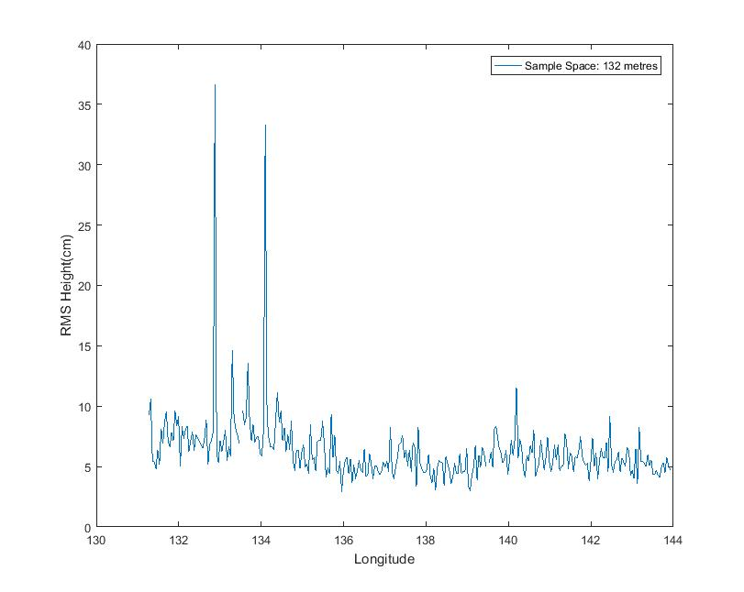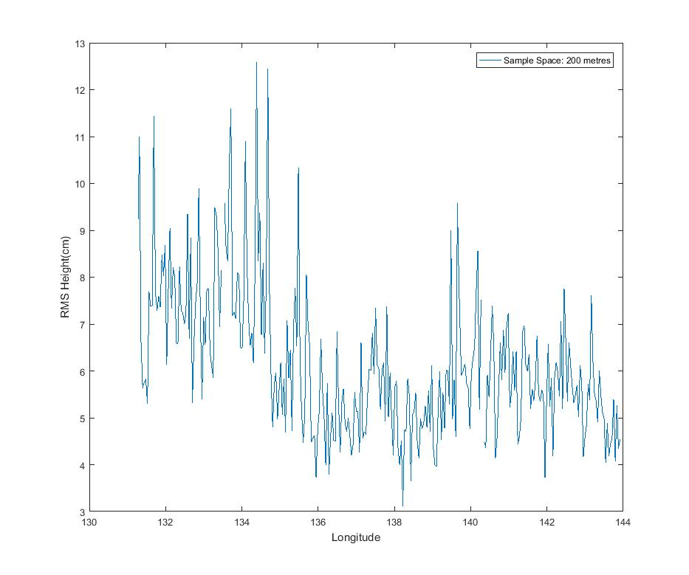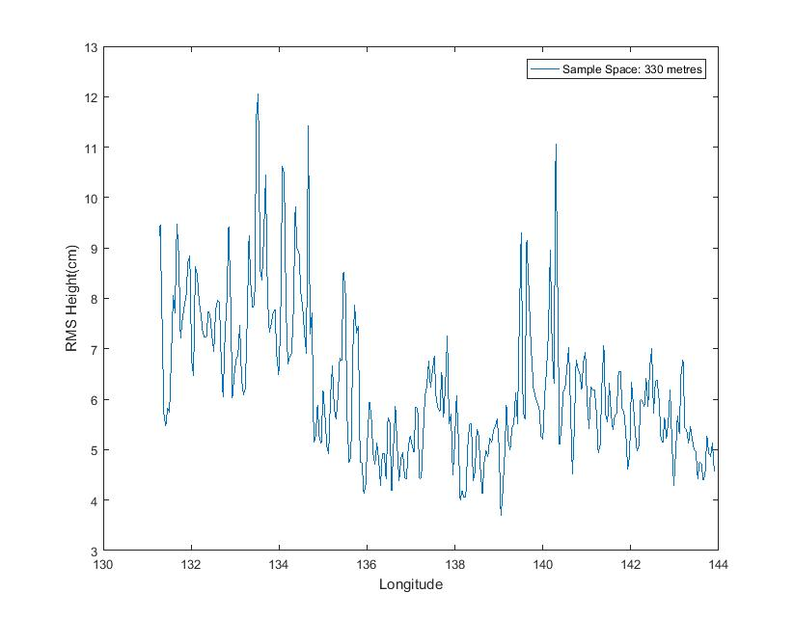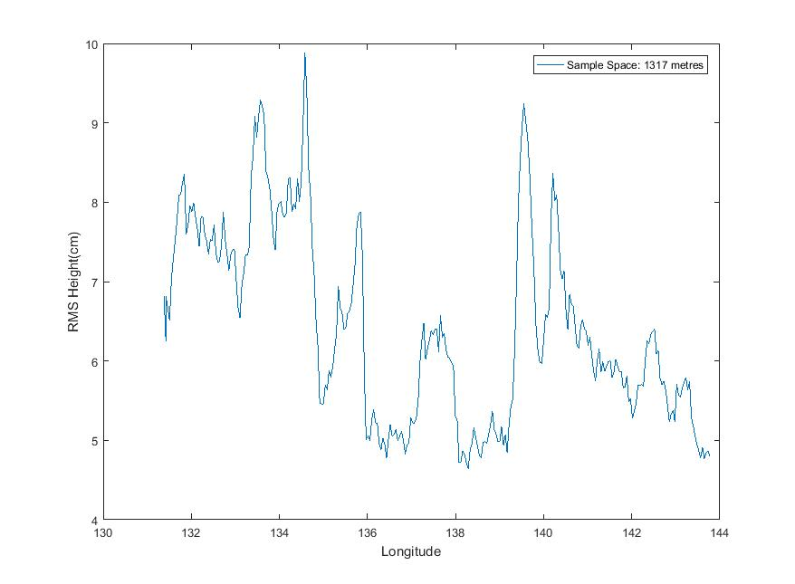

Fig. Effects of sample space on roughness calculation for 132 m, 200 m, 330 m and 1317 m

Since the roughness measurement at 200m matched closely with laser RMS while maintaining the local variations in roughness the sample space of 200m was used which also had enough samples for stable statistics. The echo amplitudes of the ice surface and ice bed are thus fitted using rice distribution for every 200 m with overlapping of every 100m to calculate the coherent and incoherent powers and then from power statistics, derive the RMS height of the surface [191].

*Sensitivity to surface tracking*

For calculation of roughness statistics it is imperative that the surface amplitude values given to the fitting are proper and representative of the actual surface otherwise the fitting may yield coherent and incoherent powers improperly. Here the automatic tracker of CReSIS is used and is expected to be accurate enough. Sometimes due to incorrect tracking at rougher interfaces few values are different however the overall roughness as a whole has matched the expected results.

**5.3 Roughness Measurements from ATM**

In addition to the roughness measurement calculations from MCoRDS, ATM has also supplemented these calculations. Airborne Topographic Mapper (ATM), airborne laser altimeter measures the surface elevation based on the two-way travel time of laser pulses along with the differential GPS and aircraft attitude information. The along-track resolution spacing is usually 3-4 m with laser footprint of ~1m. The primary data product of ATM is QFIT, which is dense surface elevation measurements []. A QFIT file is a collection of geolocated laser shots tagged with time and elevation. It is condensed resampled into ICESSN which fits a plane to the block of points selected at regular intervals (0.5 sec) along track with overlapping of 50% between successive blocks [2017]. The radar lines of MCoRDS coincide with the track 0 of ICESSN data. ICESSN data has along-track resolution of 80 meters and hence the RMS height from this laser system is calculated by the interpolation for the corresponding radar locations. It can be seen that the roughness patterns for these two systems match closely with each other.

**5.4 Roughness Measurements from KuBand Altimeter**

In addition, Operation IceBridge missions also employ the Ku-band altimeter developed by CReSIS which is an Ultra Wideband Frequency (UWB) Modulated Continuous wave Wave (FMCW) radar operating usually from 12-18 GHz [2119]. It provides high precision surface elevation measurements over polar ice sheets. The along-track resolution interval of the data from the Ku- band altimeter is about 0.2 meters after hardware presums.

**5.5 Application**

The radar data used for analysis were collected by CReSIS using MCoRDS in 2010-2014 season in Greenland. The particular segment 20141026_02 from Antarctica, as shown in the red line in Fig.1, is used to analyze the validity of the above methods because of the good quality of data, and the variable surface roughness as seen from the Ku-band altimeter in Fig. 2. Areas with smooth surface can be seen in Fig. 2a and rougher surface from Fig. 2b with their corresponding Ku-band radar echograms in Fig. 2c and Fig. 2d.

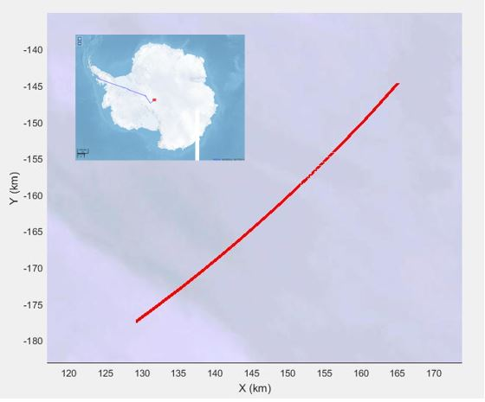

The amplitude distribution is fitted to the Rician distribution for every 500 data records from MCoRDS (i.e. about 200-m along-track distance) to derive the surface RMS height according to Eq. (3) to Eq. (6). For the purpose of validation, the RMS height was also derived for the corresponding radar locations using Ku-band and laser altimeter data. Figure 3 shows the comparison between the surface roughness measurements obtained from three systems, with the red indicating radar, blue indicating laser and green indicating Ku-band measurements. It can be clearly observed that the RMS height calculated corresponds to the surface features seen in the Ku-band altimeter image. The rougher surface features from the echogram coincide with the corresponding higher value of RMS height whereas same for the comparatively smoother surfaces of lower RMS value.

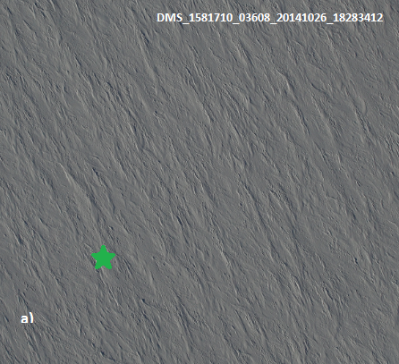 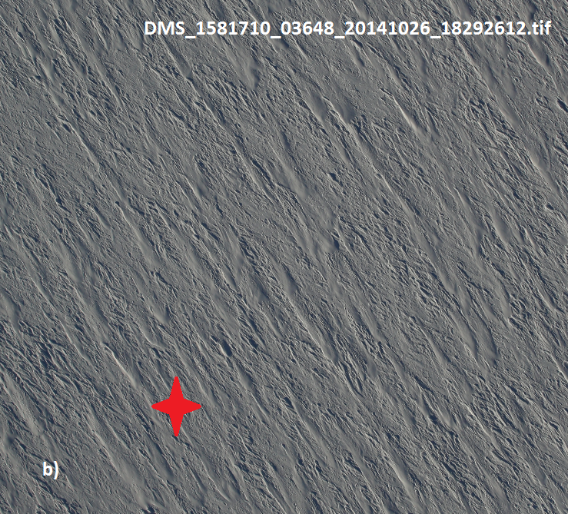

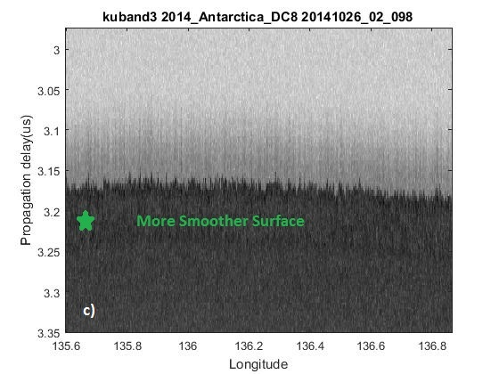 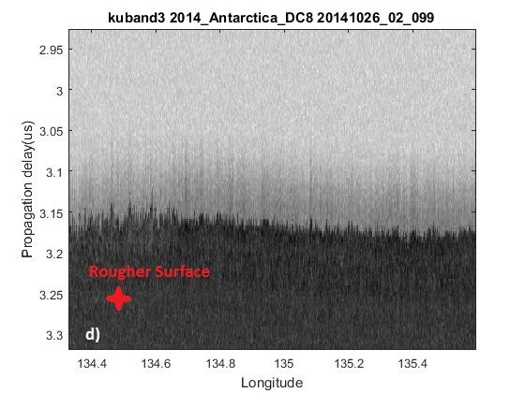

Fig.2. DMS pictures of areas with Smoother (a) and Rougher (b) Surfaces [29]. Radar Echograms obtained from Ku-band altimeter

showing corresponding smoother (a) and rougher areas (b)

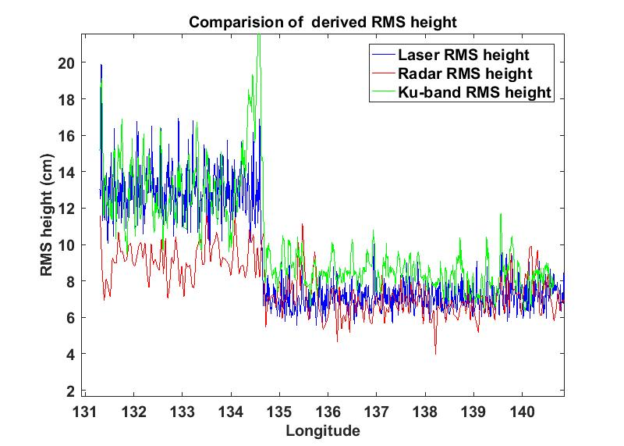

Fig. 3. Surface RMS heights obtained from MCoRDS (red), ATM (blue) and Ku-band altimeter (green)

It can be distinguished that the areas with higher RMS in laser data are also seen rough by the radar. However there is a certain bias which can be owed to the facts that these are two different systems operating with different system parameters and surface roughness is the inherent property of radar specifications [22]. The RMS heights detected by radar are bounded for rougher area and this might be the more evident amplitude fading effects with increasing roughness [19]. In addition, the RMS heights derived from the Ku-band altimeter measurements are similar.

Following the comparisons and verifications, we used the same method to determine the surface and bed roughness of Peterman Glacier and Jacobshavn glacier, which can be later used to calibrate the calculation of the ice bed reflectivity and are explained in Chapter 6.